**Table A1:** Summary of the total number of differentially expressed annotated superTranscriptome clusters resulting from 6, 12, and 24 h of TFM exposure in sea lamprey and bluegill. Up and down represents if the cluster/gene was upregulated or downregulated against respective controls.

|  |  |  |  |  |  |  |  |  |
| --- | --- | --- | --- | --- | --- | --- | --- | --- |
| **Species** | **Tissue** | **Measure** | **Exposure duration (h)** | | | | | |
|  |  |  | 6 | | 12 | | 24 | |
|  |  |  | Up | Down | Up | Down | Up | Down |
| ***Sea lamprey*** |  |  |  | |  | |  | |
|  |  |  |  | |  | |  | |
|  | *Gills* |  |  |  |  |  |  |  |
|  |  | Annotated Clusters | 35 | 15 | 3 | 1 | 1799 | 1015 |
|  |  |  |  |  |  |  |  |  |
|  |  |  |  | |  | |  | |
|  | *Liver* |  |  |  |  |  |  |  |
|  |  | Annotated Clusters | 0 | 0 | 0 | 0 | 519 | 271 |
|  |  |  |  |  |  |  |  |  |
|  |  |  |  | |  | |  | |
| ***Bluegill*** |  |  |  | |  | |  | |
|  |  |  |  | |  | |  | |
|  | *Gills* |  |  |  |  |  |  |  |
|  |  | Annotated Clusters | 269 | 170 | 1052 | 756 | 1546 | 1612 |
|  |  |  |  |  |  |  |  |  |
|  |  |  |  | |  | |  | |
|  | *Liver* |  |  |  |  |  |  |  |
|  |  | Annotated Clusters | 117 | 151 | 588 | 394 | 2279 | 1776 |
|  |  |  |  |  |  |  |  |  |

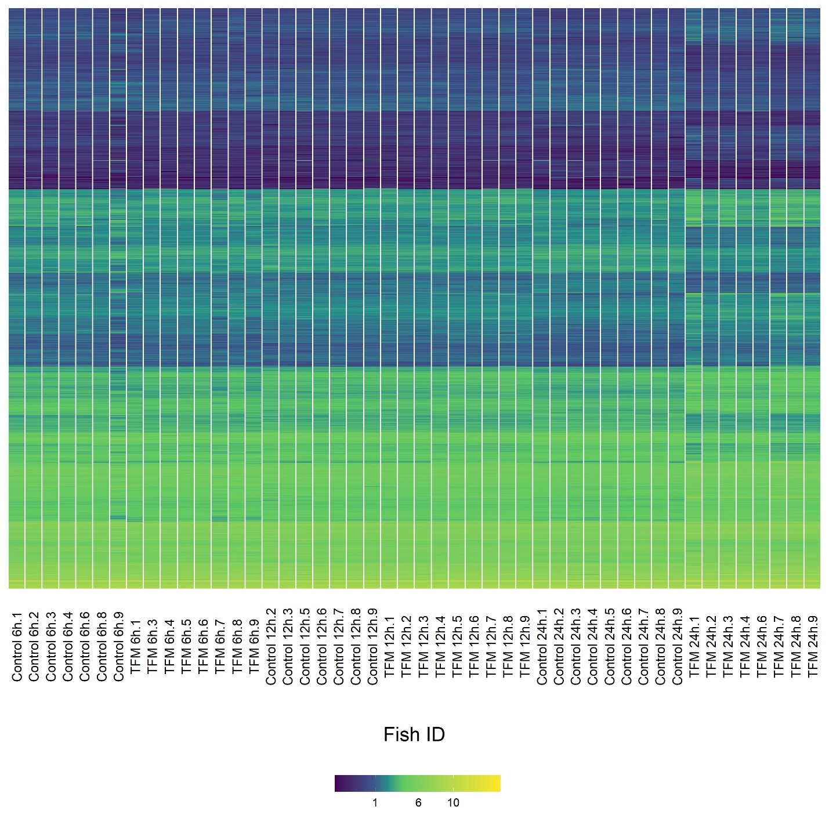

**Figure A1:** Heatmaps detailing the gene expression patterns of all differentially expressed superTranscriptome clusters in the gills of individual sea lamprey (*Petromyzon marinus*) exposed to either a control or 3-trifluoromethyl-4-nitrophenol (TFM; [TFM] = 2.21 mg L-1) exposure at 6, 12, and 24 h. Each row represents a unique and differentially expressed superTranscriptome cluster with columns arranged by both treatment group (TFM vs control) and exposure duration (6, 12, 24 h). Values represent the log counts per million with differential expressed genes being statistically significant at α = 0.05 (corrected for false discovery rate via Benjamini-Hochberg procedure).

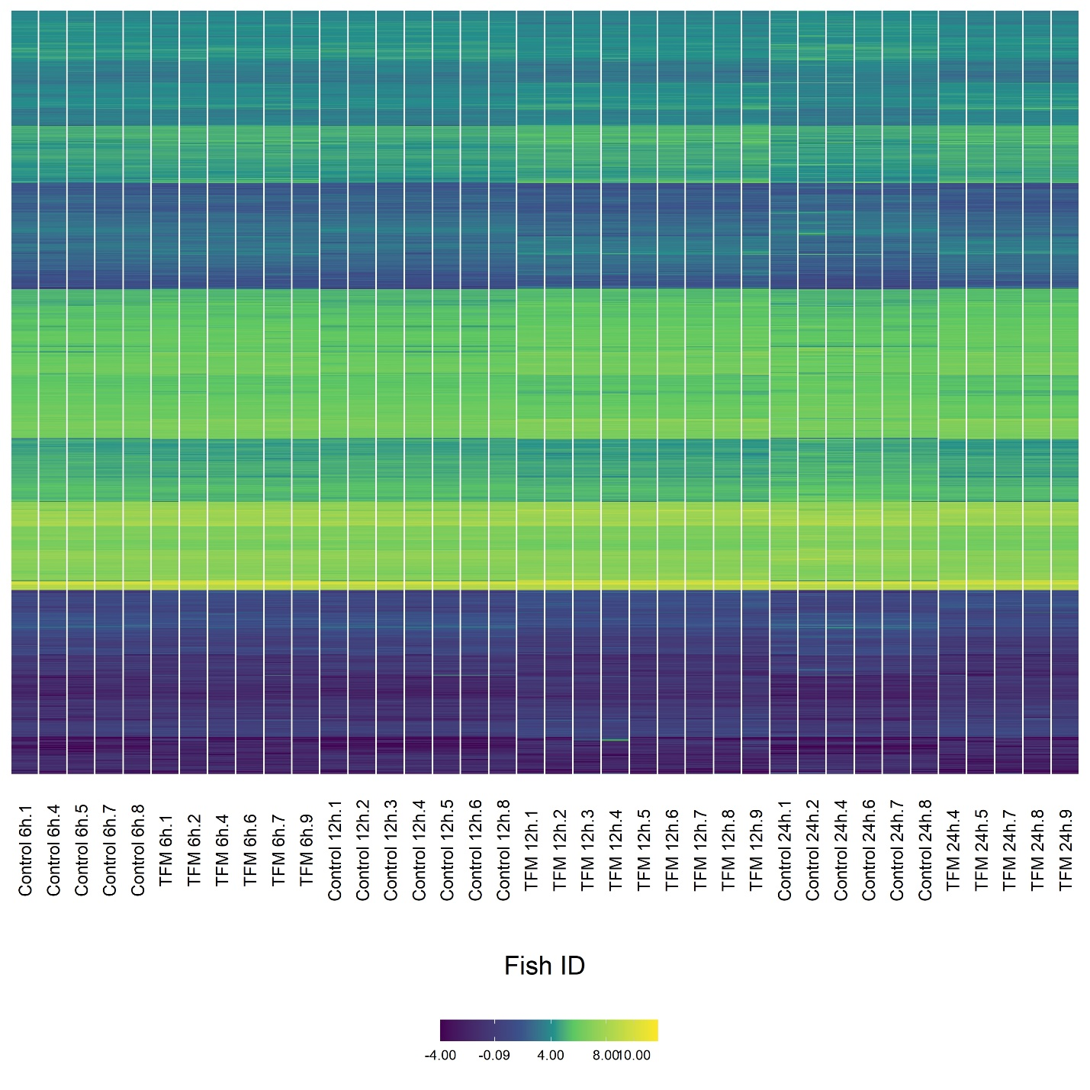

**Figure A2:** Heatmaps detailing the gene expression patterns of all differentially expressed superTranscriptome clusters in the gills of individual bluegill (*Lepomis macrochirus*) exposed to either a control or 3-trifluoromethyl-4-nitrophenol (TFM; [TFM] = 22.06 mg L-1) exposure at 6, 12, and 24 h. Each row represents a unique superTranscriptome cluster with columns arranged by both treatment group (TFM vs control) and exposure duration (6, 12, 24 h). Values represent the log counts per million with differential expressed genes being statistically significant at α = 0.05 (corrected for false discovery rate via Benjamini-Hochberg procedure).

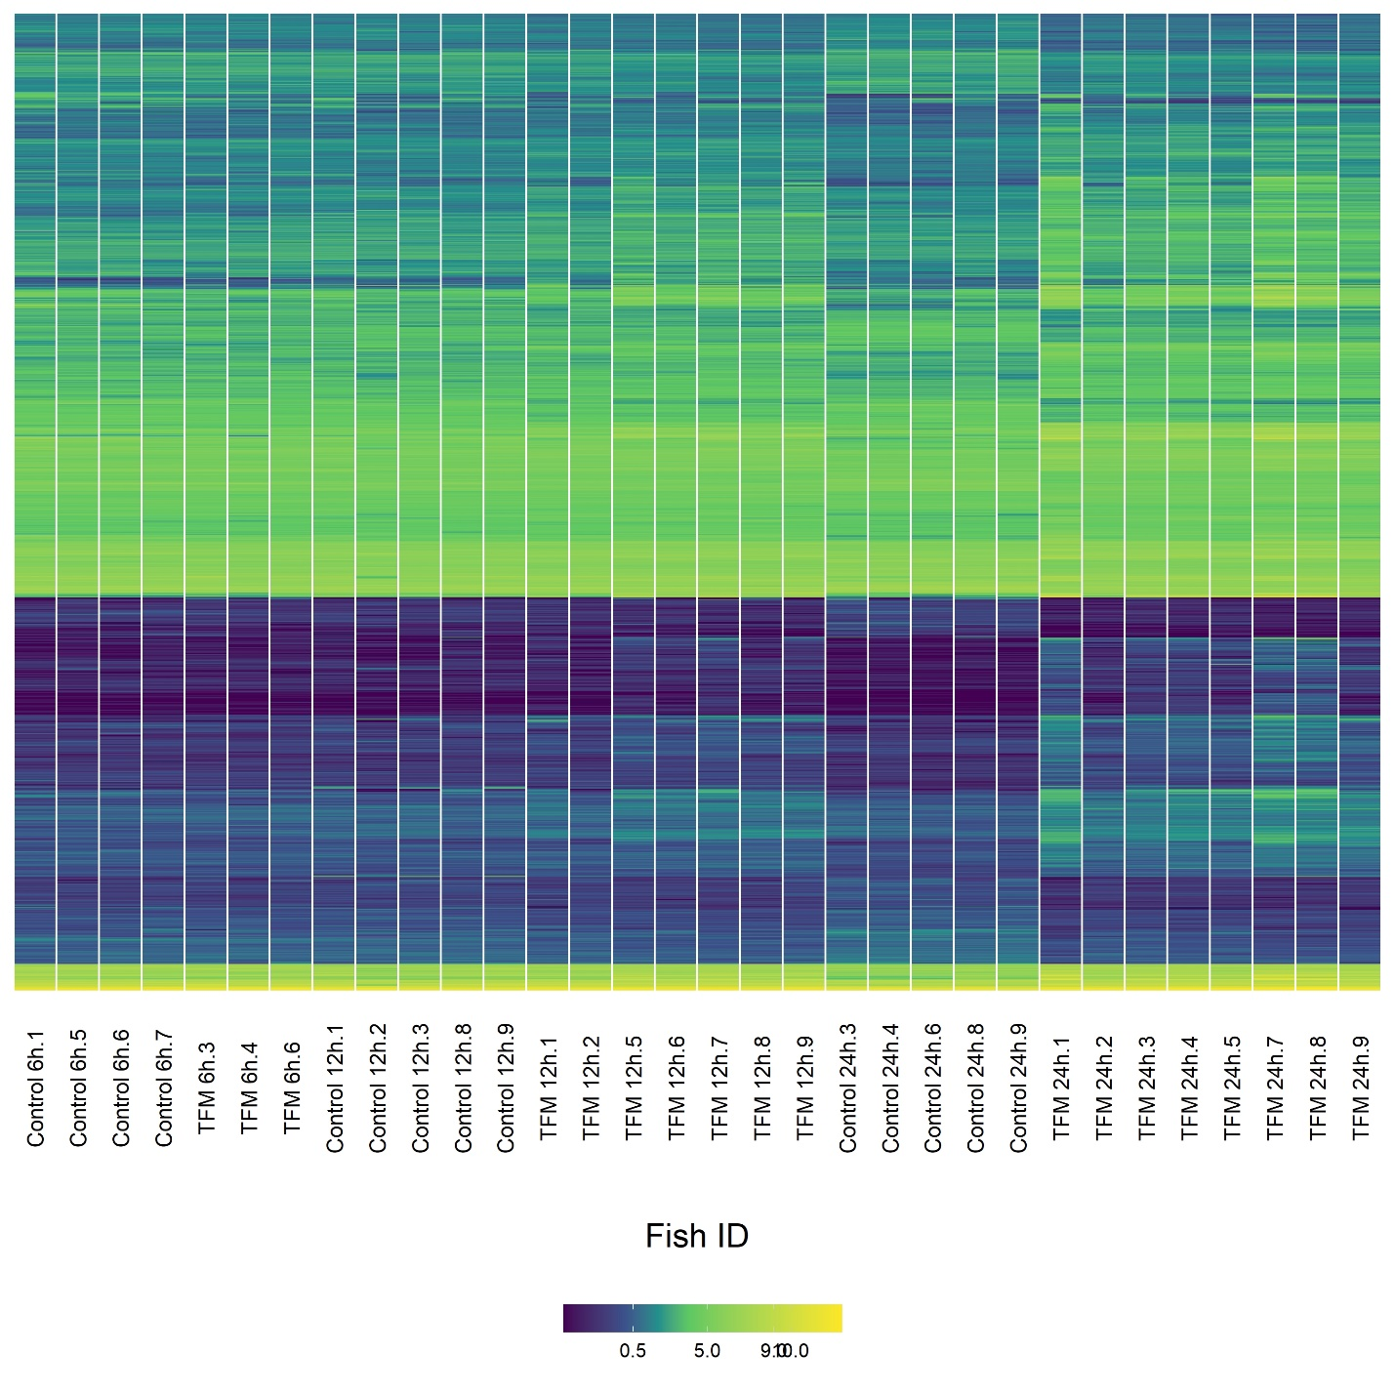

**Figure A3:** Heatmaps detailing the gene expression patterns of all differentially expressed superTranscriptome clusters in the liver of individual sea lamprey (*Petromyzon marinus*) exposed to either a control or 3-trifluoromethyl-4-nitrophenol (TFM; [TFM] = 2.21 mg L-1) exposure at 6, 12, and 24 h. Each row represents a unique superTranscriptome cluster with columns arranged by both treatment group (TFM vs control) and exposure duration (6, 12, 24 h). Values represent the log counts per million with differential expressed genes being statistically significant at α = 0.05 (corrected for false discovery rate via Benjamini-Hochberg procedure).

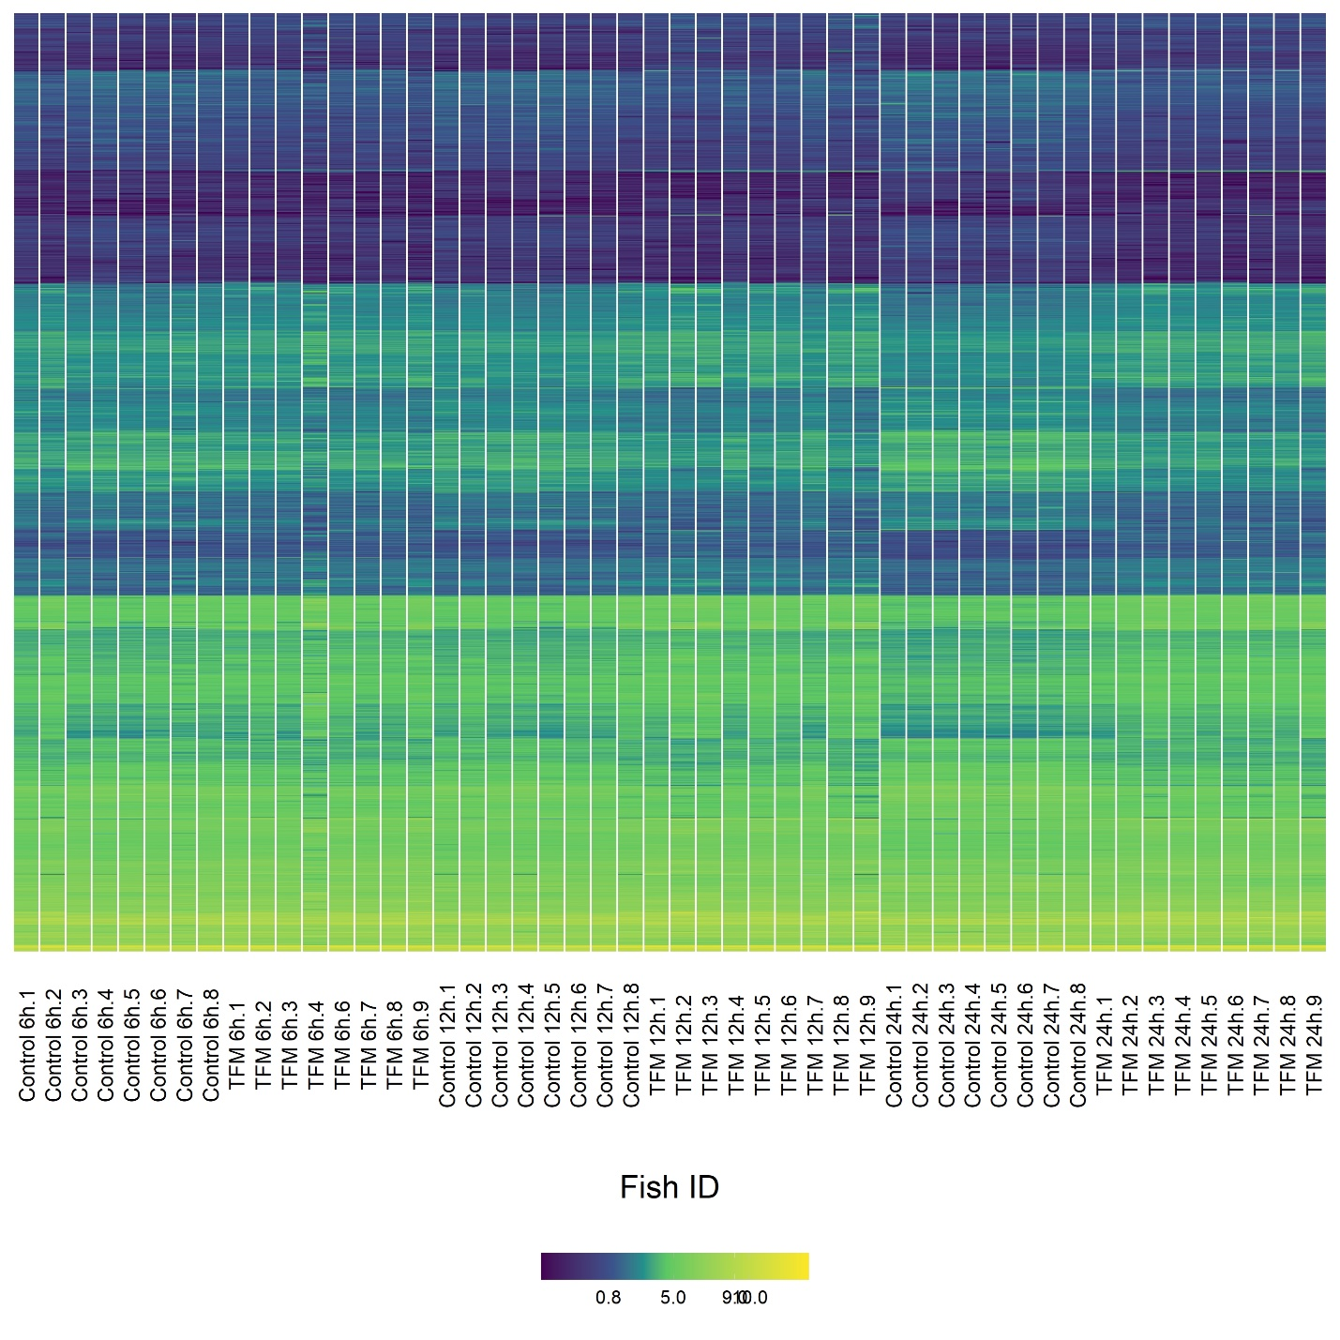

**Figure A4:** Heatmaps detailing the gene expression patterns in the liver of individual bluegill (*Lepomis macrochirus*) exposed to either a control or 3-trifluoromethyl-4-nitrophenol (TFM; [TFM] = 22.06 mg L-1) exposure at 6, 12, and 24 h. Each row represents a unique superTranscriptome cluster with columns arranged by both treatment group (TFM vs control) and exposure duration (6, 12, 24 h). Values represent the log counts per million with differential expressed genes being statistically significant at α = 0.05 (corrected for false discovery rate via Benjamini-Hochberg procedure).

**Figure A5:** Principal component analysis (PCA) of sea lamprey (*Petromyzon marinus*) gene expression in the gills exposed to control (blue, purple, cyan) or 3-trifluoromethyl-4-nitrophenol (TFM; 2.21 mg L-1; red, yellow, brown) being sampled at 6 h (circles), 12 h (squares), or 24 h (triangles).

**Figure A6:** Principal component analysis (PCA) of bluegill (*Lepomis macrochirus*) gene expression in the gills of fish exposed to control (blue, purple, cyan) or 3-trifluoromethyl-4-nitrophenol (TFM; 2.21 mg L-1; red, yellow, brown) being sampled at 6 h (circles), 12 h (squares), or 24 h (triangles).

**Figure A7:** Principal component analysis (PCA) of sea lamprey (*Petromyzon marinus*) gene expression in the livers of fish exposed to control (blue, purple, cyan) or 3-trifluoromethyl-4-nitrophenol (TFM; 2.21 mg L-1; red, yellow, brown) being sampled at 6 h (circles), 12 h (squares), or 24 h (triangles).

**Figure A8:** Principal component analysis (PCA) of bluegill (*Lepomis macrochirus*) gene expression in the livers of fish exposed to control (blue, purple, cyan) or 3-trifluoromethyl-4-nitrophenol (TFM; 2.21 mg L-1; red, yellow, brown) being sampled at 6 h (circles), 12 h (squares), or 24 h (triangles).



**Figure A9:** Summary of enriched gene ontology (GO) terms associated with biological processes in transcripts that were upregulated following 6 h of TFM (3-trifluoromethyl-4'-nitrophenol; 2.21 mg L-1 nominal) exposure in the gills of sea lamprey (*Petromyzon marinus*) larvae. Transcripts were considered differentially regulated at a false discovery rate < 0.05. Only GO terms from the functional analysis with an adjusted p < 0.05 and at least four transcripts were considered significantly enriched. REVIGO was used to summarize GO terms to reduce redundancy and group according to similarity (right labels).



**Figure A10:** Summary of enriched gene ontology (GO) terms associated with biological processes in transcripts that were upregulated following 24 h of TFM (3-trifluoromethyl-4'-nitrophenol; 2.21 mg L-1 nominal) exposure in the gills of sea lamprey (*Petromyzon marinus*) larvae. Transcripts were considered differentially regulated at a false discovery rate < 0.05. Only GO terms from the functional analysis with an adjusted p < 0.05 and at least four transcripts were considered significantly enriched. REVIGO was used to summarize GO terms to reduce redundancy and group according to similarity (right labels).



**Figure A11:** Summary of enriched gene ontology (GO) terms associated with molecular functions in transcripts that were upregulated following 24 h of TFM (3-trifluoromethyl-4'-nitrophenol; 2.21 mg L-1 nominal) exposure in the gills of sea lamprey (*Petromyzon marinus*) larvae. Transcripts were considered differentially regulated at a false discovery rate < 0.05. Only GO terms from the functional analysis with an adjusted p < 0.05 and at least four transcripts were considered significantly enriched. REVIGO was used to summarize GO terms to reduce redundancy and group according to similarity (right labels).



**Figure A12:** Summary of enriched gene ontology (GO) terms associated with biological processes (green) and molecular functions (blue) in transcripts that were downregulated following 24 h of TFM (3-trifluoromethyl-4'-nitrophenol; 2.21 mg L-1 nominal) exposure in the gills of sea lamprey (*Petromyzon marinus*) larvae. Transcripts were considered differentially regulated at a false discovery rate < 0.05. Only GO terms from the functional analysis with an adjusted p < 0.05 and at least four transcripts were considered significantly enriched. REVIGO was used to summarize GO terms to reduce redundancy and group according to similarity (right labels).



**Figure A13:** Summary of enriched gene ontology (GO) terms associated with molecular functions in transcripts that were upregulated following 24 h of TFM (3-trifluoromethyl-4'-nitrophenol; 2.21 mg L-1 nominal) exposure in the liver of sea lamprey (*Petromyzon marinus*) larvae. Transcripts were considered differentially regulated at a false discovery rate < 0.05. Only GO terms from the functional analysis with an adjusted p < 0.05 and at least four transcripts were considered significantly enriched. REVIGO was used to summarize GO terms to reduce redundancy and group according to similarity (right labels).



**Figure A14:** Summary of enriched gene ontology (GO) terms associated with biological processes in transcripts that were downregulated following 24 h of TFM (3-trifluoromethyl-4'-nitrophenol; 2.21 mg L-1 nominal) exposure in the liver of sea lamprey (*Petromyzon marinus*) larvae. Transcripts were considered differentially regulated at a false discovery rate < 0.05. Only GO terms from the functional analysis with an adjusted p < 0.05 and at least four transcripts were considered significantly enriched. REVIGO was used to summarize GO terms to reduce redundancy and group according to similarity (right labels).



**Figure A15:** Summary of enriched gene ontology (GO) terms associated with biological processes (green) and molecular functions (blue) in transcripts that were upregulated following 6 h of TFM (3-trifluoromethyl-4'-nitrophenol; 22.06 mg L-1 nominal) exposure in the gills of bluegill (*Lepomis macrochirus*). Transcripts were considered differentially regulated at a false discovery rate < 0.05. Only GO terms from the functional analysis with an adjusted p < 0.05 and at least four transcripts were considered significantly enriched. REVIGO was used to summarize GO terms to reduce redundancy and group according to similarity (right labels).



**Figure A16:** Summary of enriched gene ontology (GO) terms associated with biological processes (green) and molecular functions (blue) in transcripts that were downregulated following 6 h of TFM (3-trifluoromethyl-4'-nitrophenol; 22.06 mg L-1 nominal) exposure in the gills of bluegill (*Lepomis macrochirus*). Transcripts were considered differentially regulated at a false discovery rate < 0.05. Only GO terms from the functional analysis with an adjusted p < 0.05 and at least four transcripts were considered significantly enriched. REVIGO was used to summarize GO terms to reduce redundancy and group according to similarity (right labels).



**Figure A17:** Summary of enriched gene ontology (GO) terms associated with biological processes (green) and molecular functions (blue) in transcripts that were upregulated following 12 h of TFM (3-trifluoromethyl-4'-nitrophenol; 22.06 mg L-1 nominal) exposure in the gills of bluegill (*Lepomis macrochirus*). Transcripts were considered differentially regulated at a false discovery rate < 0.05. Only GO terms from the functional analysis with an adjusted p < 0.05 and at least four transcripts were considered significantly enriched. REVIGO was used to summarize GO terms to reduce redundancy and group according to similarity (right labels).



**Figure A18:** Summary of enriched gene ontology (GO) terms associated with biological processes in transcripts that were downregulated following 12 h of TFM (3-trifluoromethyl-4'-nitrophenol; 22.06 mg L-1 nominal) exposure in the gills of bluegill (*Lepomis macrochirus*). Transcripts were considered differentially regulated at a false discovery rate < 0.05. Only GO terms from the functional analysis with an adjusted p < 0.05 and at least four transcripts were considered significantly enriched. REVIGO was used to summarize GO terms to reduce redundancy and group according to similarity (right labels).



**Figure A19:** Summary of enriched gene ontology (GO) terms associated with biological processes (green) and molecular functions (blue) in transcripts that were upregulated following 24 h of TFM (3-trifluoromethyl-4'-nitrophenol; 22.06 mg L-1 nominal) exposure in the gills of bluegill (*Lepomis macrochirus*). Transcripts were considered differentially regulated at a false discovery rate < 0.05. Only GO terms from the functional analysis with an adjusted p < 0.05 and at least four transcripts were considered significantly enriched. REVIGO was used to summarize GO terms to reduce redundancy and group according to similarity (right labels).



**Figure A20:** Summary of enriched gene ontology (GO) terms associated with biological processes (green) and molecular functions (blue) in transcripts that were downregulated following 24 h of TFM (3-trifluoromethyl-4'-nitrophenol; 22.06 mg L-1 nominal) exposure in the gills of bluegill (*Lepomis macrochirus*). Transcripts were considered differentially regulated at a false discovery rate < 0.05. Only GO terms from the functional analysis with an adjusted p < 0.05 and at least four transcripts were considered significantly enriched. REVIGO was used to summarize GO terms to reduce redundancy and group according to similarity (right labels).



**Figure A21:** Summary of enriched gene ontology (GO) terms associated with biological processes in transcripts that were downregulated following 6 h of TFM (3-trifluoromethyl-4'-nitrophenol; 22.06 mg L-1 nominal) exposure in the liver of bluegill (*Lepomis macrochirus*). Transcripts were considered differentially regulated at a false discovery rate < 0.05. Only GO terms from the functional analysis with an adjusted p < 0.05 and at least four transcripts were considered significantly enriched. REVIGO was used to summarize GO terms to reduce redundancy and group according to similarity (right labels).



**Figure A22:** Summary of enriched gene ontology (GO) terms associated with biological processes (green) and molecular functions (blue) in transcripts that were upregulated following 12 h of TFM (3-trifluoromethyl-4'-nitrophenol; 22.06 mg L-1 nominal) exposure in the liver of bluegill (*Lepomis macrochirus*). Transcripts were considered differentially regulated at a false discovery rate < 0.05. Only GO terms from the functional analysis with an adjusted p < 0.05 and at least four transcripts were considered significantly enriched. REVIGO was used to summarize GO terms to reduce redundancy and group according to similarity (right labels).



**Figure A23:** Summary of enriched gene ontology (GO) terms associated with biological processes (green) and molecular functions (blue) in transcripts that were downregulated following 12 h of TFM (3-trifluoromethyl-4'-nitrophenol; 22.06 mg L-1 nominal) exposure in the liver of bluegill (*Lepomis macrochirus*). Transcripts were considered differentially regulated at a false discovery rate < 0.05. Only GO terms from the functional analysis with an adjusted p < 0.05 and at least four transcripts were considered significantly enriched. REVIGO was used to summarize GO terms to reduce redundancy and group according to similarity (right labels).



**Figure A24:** Summary of enriched gene ontology (GO) terms associated with biological processes (green) and molecular functions (blue) in transcripts that were upregulated following 24 h of TFM (3-trifluoromethyl-4'-nitrophenol; 22.06 mg L-1 nominal) exposure in the liver of bluegill (*Lepomis macrochirus*). Transcripts were considered differentially regulated at a false discovery rate < 0.05. Only GO terms from the functional analysis with an adjusted p < 0.05 and at least four transcripts were considered significantly enriched. REVIGO was used to summarize GO terms to reduce redundancy and group according to similarity (right labels).



**Figure A25:** Summary of enriched gene ontology (GO) terms associated with molecular functions in transcripts that were downregulated following 24 h of TFM (3-trifluoromethyl-4'-nitrophenol; 22.06 mg L-1 nominal) exposure in the liver of bluegill (*Lepomis macrochirus*). Transcripts were considered differentially regulated at a false discovery rate < 0.05. Only GO terms from the functional analysis with an adjusted p < 0.05 and at least four transcripts were considered significantly enriched. REVIGO was used to summarize GO terms to reduce redundancy and group according to similarity (right labels).